HORTICULTURAL CENTRE OF THE CITY OF PARIS
What the center does
This center primarily plants and grows multiple types of flowers. Plants and trees for decorative purposes exclusively in Paris.
They aren’t allowed to sell the flowers and plants to other places unless it is allowed (or they have extras).
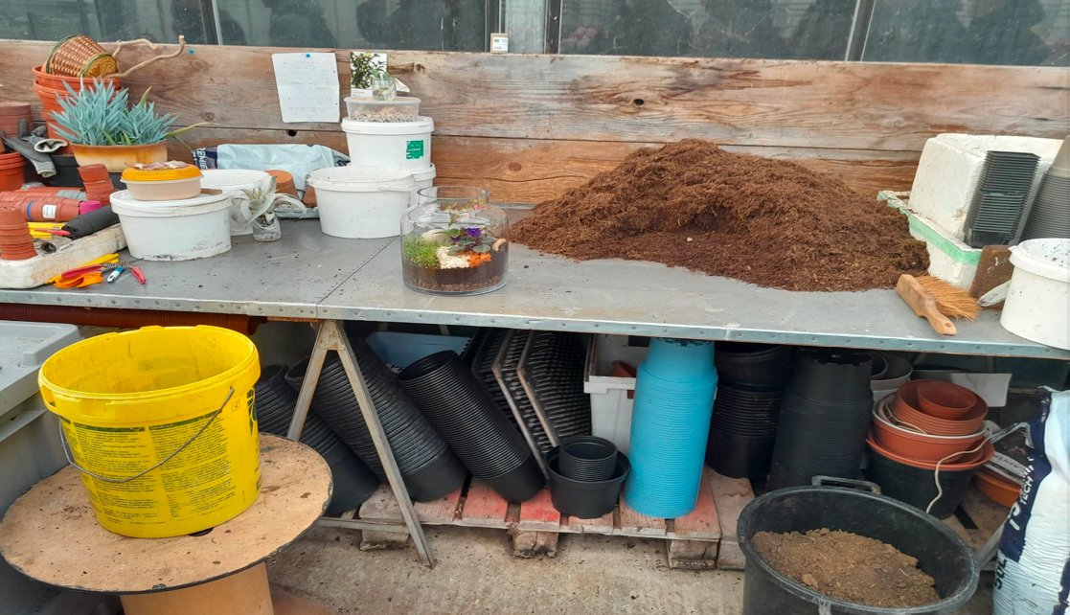

Plant watering mechanism
Due to the fact they need to manage hundreds to thousands of plants in a set amount of time, instead of watering them all separately, a manually commanded operating system is used. However, it works automatically and sprays everything while also being able to move. This system permits users to water the plants while doing other things simultaneously.
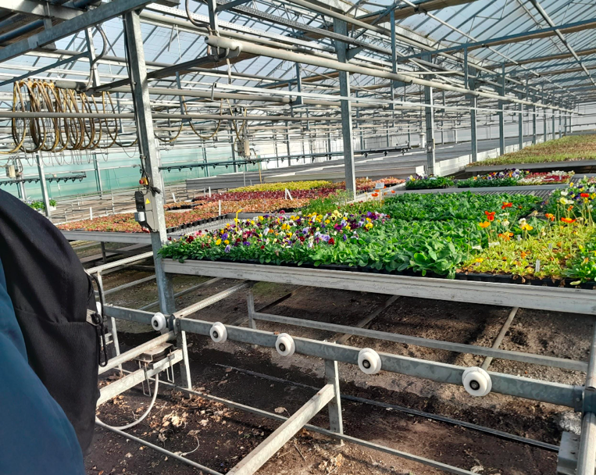
They have this conveyor system for every section of plants which can be moved manually, or maybe even mechanically, to simplify transportation.
Some plants require a certain temperature to be able to grow to obtain a certain amount of sunlight, so they are mainly put in huge rooms that have a temperature detection device which verifies the room temperature often. If it is either too hot, or too cold, it will open the roof tiles to either receive more sunlight and fresh air or just to decrease the room temperature as can be seen in the video below.
A smart greenhouse provides real-time information on critical climate factors including, temperature, humidity, light exposure and carbon dioxide across the greenhouse.

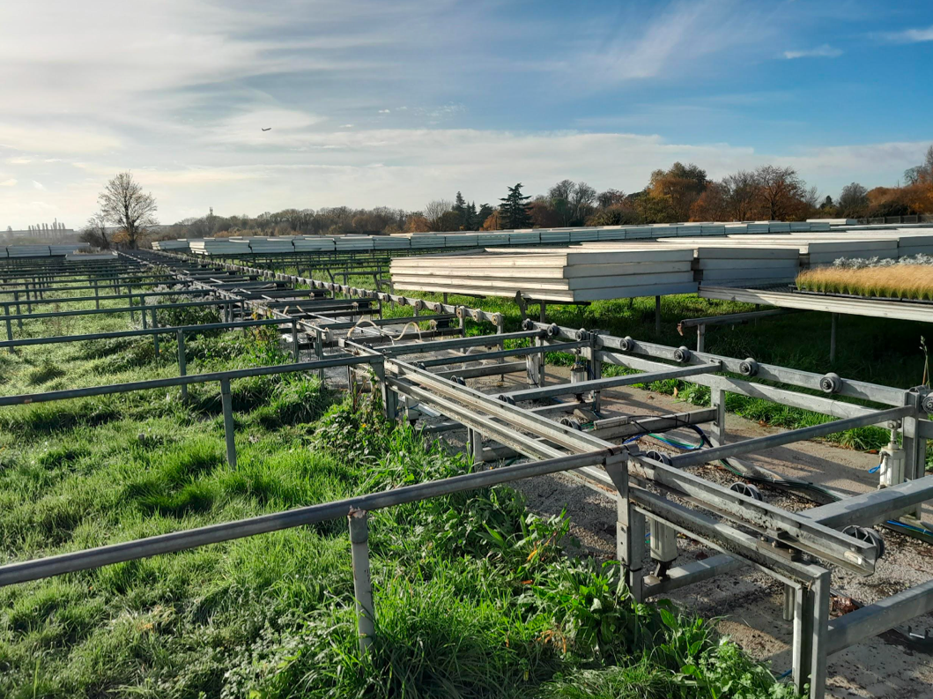

Germination process
Once the seeds have been planted in the tray, they are moved to a germination chamber where they get checked every day for growth. After reaching a certain stage, which can take up to 3 months, they are either moved to different chambers or put on one of the trays where they can receive specific doses of water and sunlight.
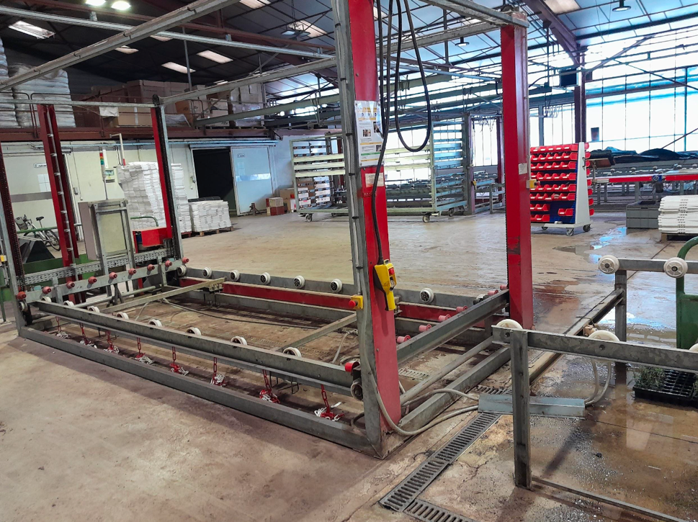

By Cheik, Anthony and Raoul

2CRSA

